Database Design
Laboratory Exercise 1

- Screenshots of each table from the design view.
  - Borrow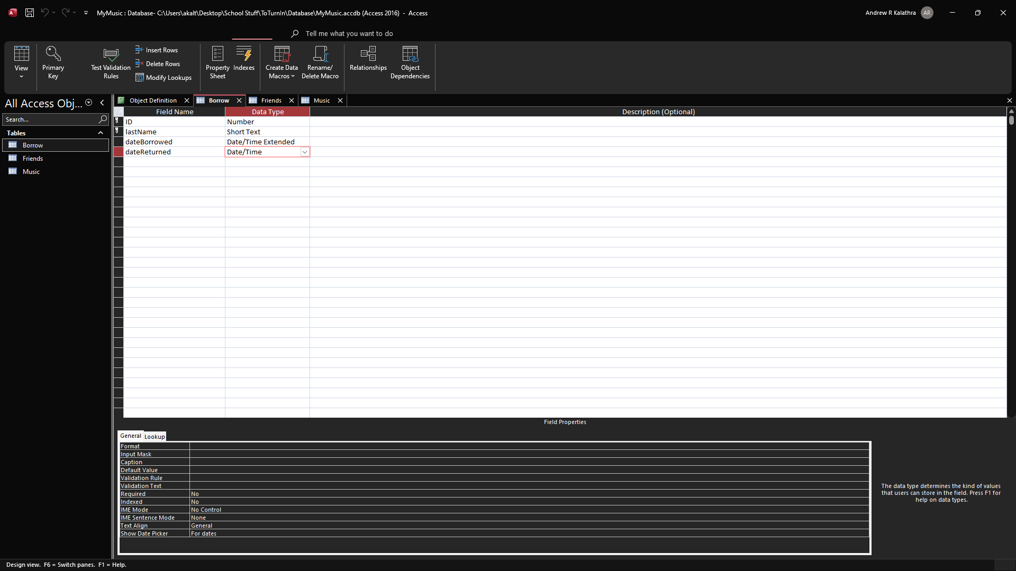
  - Friends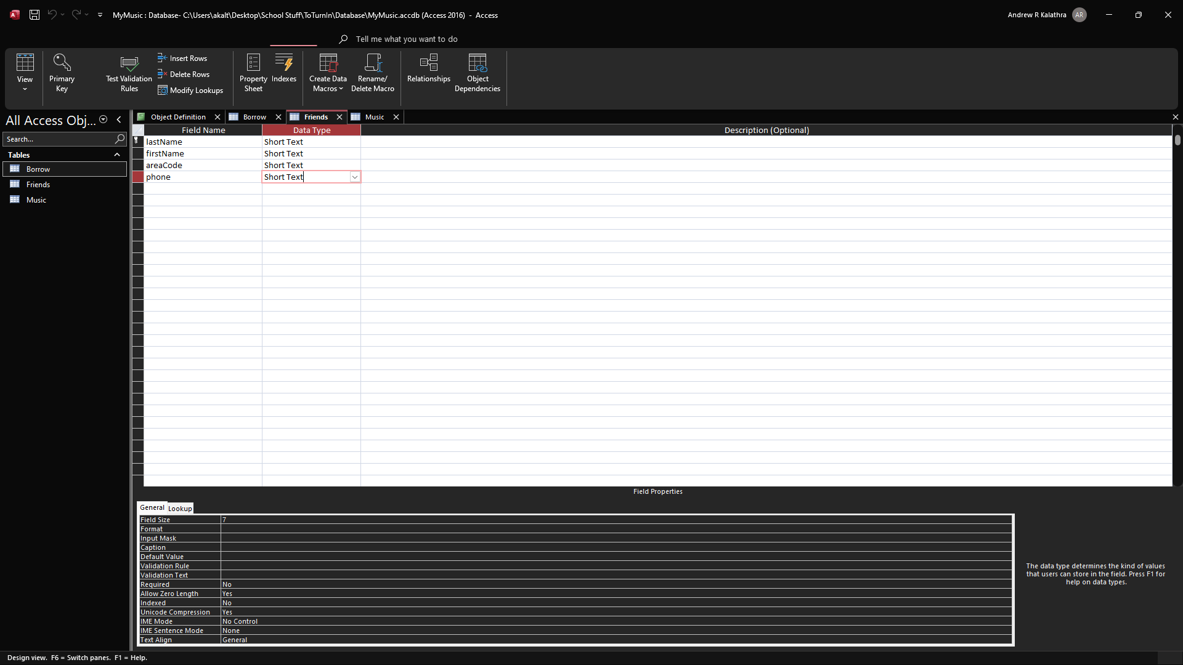
  - Music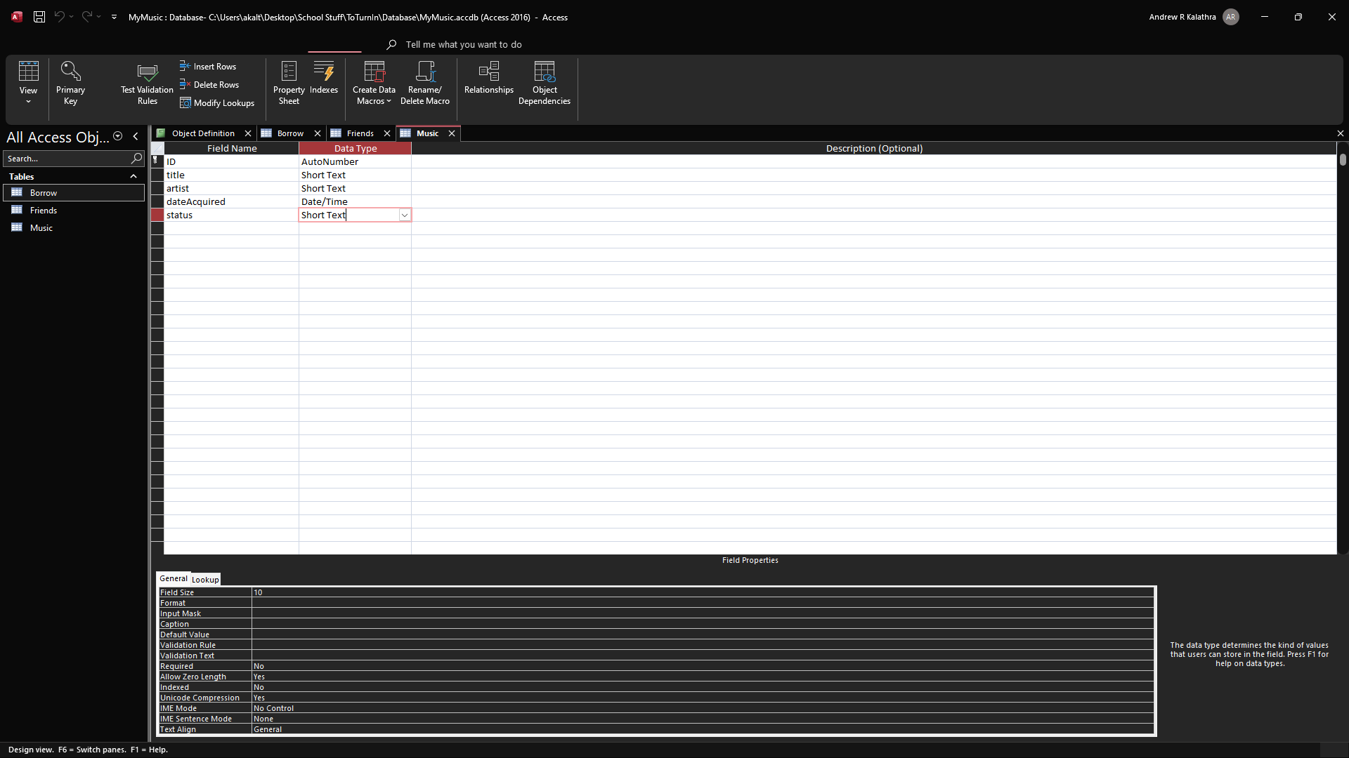

- Foreign Keys
  - ID is a foreign key of Borrow referencing Music
  - lastName is a foreign key of Borrow referencing Friends

- All types of indexes that were created for this schema, suitability, and why?
  - The Music relation was ordered by the ID attribute, which was the primary key. This means that a primary index was used. This was suitable as the ID was automatically numbered, so the order the albums were entered in determined the ID given it. The order of the album only mattered after the ID was given, which made this scheme suitable.
  - As Borrow and Friends were unordered, this scheme had to contain a secondary index. This was suitable for this scheme because the index file was small, which works well for a dense index. Alongside this, these files were not sorted on the indexed field.
  - As Borrow can have multiple friends borrowing the same music (for example), a clustering index would be most suitable for it. This is efficient for querying as information such as who had rented the music, when a certain music was rented, and what music a certain friend had rented. This information all requires pieces of data that are specific to the tuple, but specifically clustered around the attributes of the ID, date, or even name, which are all fields that could be indexed by. As this is a smaller database, it cannot be known for certain which of these three would be the most useful.
  - There are not many relationships that are common amongst the tuples found in Friend and Music, so a non-clustered index would be most suitable for these.

